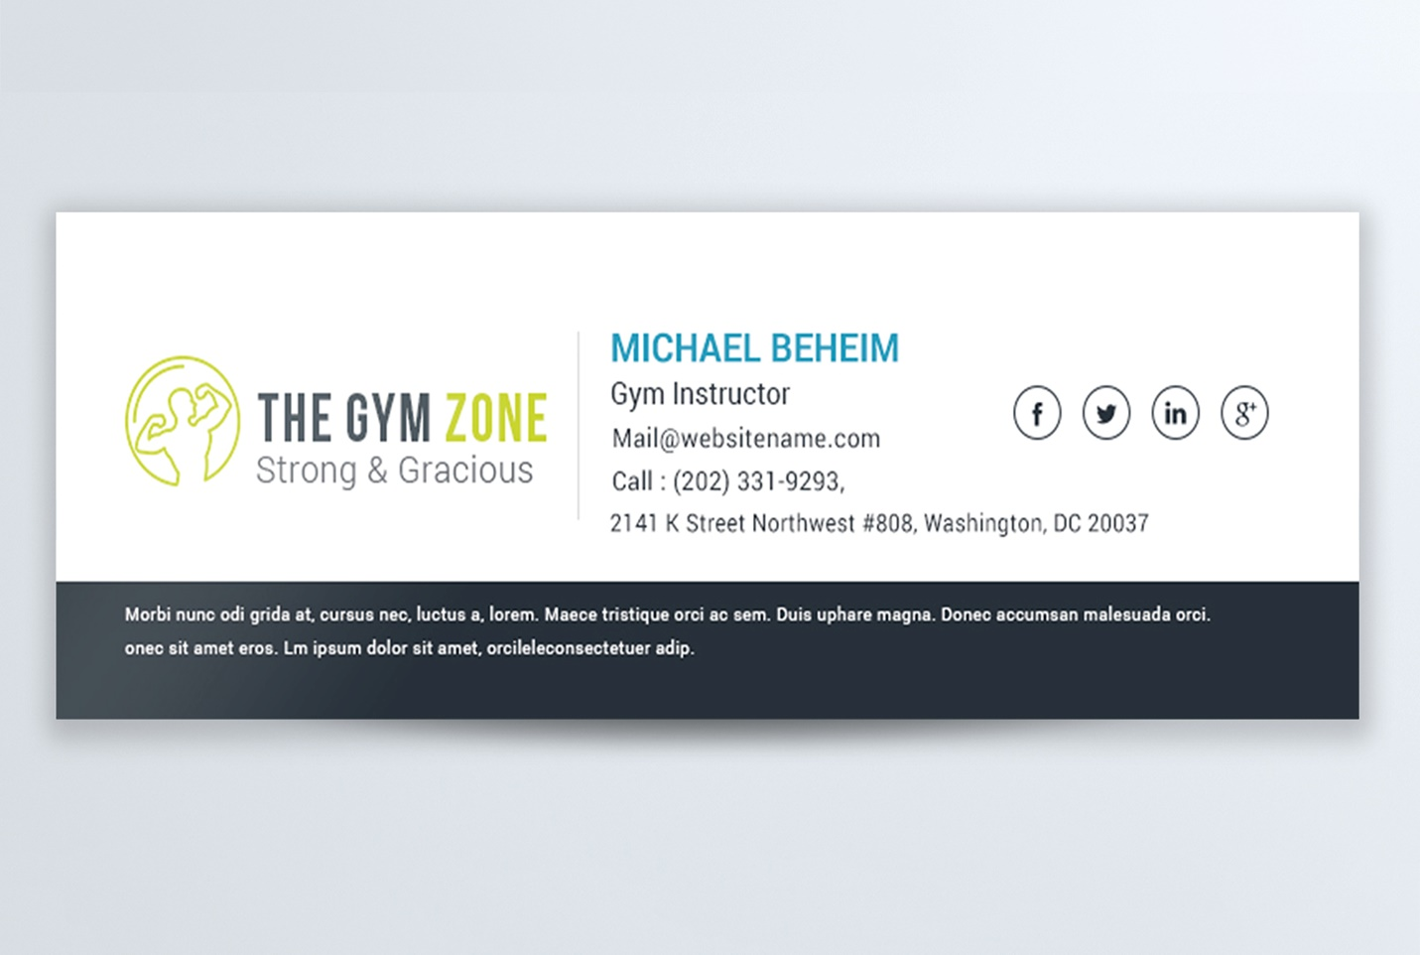

|  |  |
| --- | --- |
| **John Doe** | |
| Sales & Marketing Director | |
|  | |
| [Logo](https://www.my-company.com/) | |  | | --- | | T: (800) 555-0199 | | M: (800) 555-0299 | | [john.doe@my-company.com](mailto:john.doe@my-company.com)  [www.my-company.com](http://www.my-company.com/) | | Street, City Zip Code, Country | | [Facebook icon](https://www.facebook.com/MyCompany)  [LinkedIn icon](https://www.linkedin.com/company/mycompany404)  [Twitter icon](https://twitter.com/MyCompany404)  [Youtube icon](https://www.youtube.com/user/MyCompanyChannel)  [Instagram icon](https://www.instagram.com/mycompany404/)  [Pinterest icon](https://pinterest.com/mycompany404/) | |
|  | |

|  |  |  |  |  |  |  |  |  |  |
| --- | --- | --- | --- | --- | --- | --- | --- | --- | --- |
| [Logo](https://www.my-company.com/) | |  | | --- | | **John Doe** | | Sales & Marketing Director | | phone: (800) 555-0199 | | mobile: (800) 555-0299 | | email: john.doe@my-company.com | | Street, City | | Zip Code, Country | | [Facebook icon](https://www.facebook.com/MyCompany)  [LinkedIn icon](https://www.linkedin.com/company/mycompany404)  [Twitter icon](https://twitter.com/MyCompany404)  [Youtube icon](https://www.youtube.com/user/MyCompanyChannel)  [Instagram icon](https://www.instagram.com/mycompany404/)  [Pinterest icon](https://pinterest.com/mycompany404/) | |

|  |  |  |  |  |  |  |  |  |
| --- | --- | --- | --- | --- | --- | --- | --- | --- |
| [Logo](https://www.my-company.com/) | Logo | |  | | --- | | **John Doe** | | **Sales & Marketing Director** | | **T:**(800) 555-0199 | **M:**(800) 555-0299 | | **E:**john.doe@my-company.com  **W**: [www.my-company.com](http://www.my-company.com/) | | Street, City | Zip Code, Country | | [Facebook icon](https://www.facebook.com/MyCompany) [LinkedIn icon](https://www.linkedin.com/company/mycompany404) [Twitter icon](https://twitter.com/MyCompany404) [Youtube icon](https://www.youtube.com/user/MyCompanyChannel) [Instagram icon](https://www.instagram.com/mycompany404/) [Pinterest icon](https://pinterest.com/mycompany404/) | |
|  | | |

|  |  |  |  |  |  |  |
| --- | --- | --- | --- | --- | --- | --- |
| [Logo](https://www.my-company.com/) | |  | | --- | | **John Doe** Sales & Marketing Director | My Company | | **m:** (800) 555-0299 **p:** (800) 555-0199 **e:** john.doe@my-company.com | | Street, City Zip Code, Country | | [www.my-company.com](http://www.my-company.com/) | | [facebook icon](https://www.facebook.com/MyCompany) [twitter icon](https://twitter.com/MyCompany404) [youtube icon](https://www.youtube.com/user/MyCompanyChannel) [linkedin icon](https://www.linkedin.com/company/mycompany404) [instagram icon](https://www.instagram.com/mycompany404/) [pinterest icon](https://pinterest.com/mycompany404/) | |
|  |

|  |
| --- |
| **John Doe** |
| Sales & Marketing Director |
| Street, City • Zip Code, Country My Company |
| mobile-icon  (800) 555-0299 phone-icon  (800) 555-0199 email-icon  john.doe@my-company.com website-icon  [www.my-company.com](http://www.my-company.com/) |
| [facebook icon](https://www.facebook.com/MyCompany) [youtube icon](https://www.youtube.com/user/MyCompanyChannel) [linkedin icon](https://www.linkedin.com/company/mycompany404) [twitter icon](https://twitter.com/MyCompany404) [instagram icon](https://www.instagram.com/mycompany404/) [pinterest icon](https://pinterest.com/mycompany404/) |

|  |  |
| --- | --- |
| [Logo](https://www.my-company.com/) | **John Doe** |
| Sales & Marketing Director |
| t: (800) 555-0199 m: (800) 555-0299 e: john.doe@my-company.com |
| **My Company** Street, City Zip Code, Country |
| [**www.my-company.com**](http://www.my-company.com/) |
| [twitter icon](https://twitter.com/MyCompany404) [facebook icon](https://www.facebook.com/MyCompany) [linkedin icon](https://www.linkedin.com/company/mycompany404) [youtube icon](https://www.youtube.com/user/MyCompanyChannel) [instagram icon](https://www.instagram.com/mycompany404/) [pinterest icon](https://pinterest.com/mycompany404/) |

|  |  |  |  |  |
| --- | --- | --- | --- | --- |
| photograph | |  | | --- | | ***John Doe*** Sales & Marketing Director | | email: john.doe@my-company.com phone: (800) 555-0199  mobile: (800) 555-0299 | | My Company, Street, City Zip Code, Country | |
| [facebook icon](https://www.facebook.com/MyCompany) [twitter icon](https://twitter.com/MyCompany404) [youtube icon](https://www.youtube.com/user/MyCompanyChannel) [linkedin icon](https://www.linkedin.com/company/mycompany404) [instagram icon](https://www.instagram.com/mycompany404/) [pinterest icon](https://pinterest.com/mycompany404/) | [www.my-company.com](http://www.my-company.com/) |

|  |  |  |  |  |  |  |  |
| --- | --- | --- | --- | --- | --- | --- | --- |
| |  | | --- | | **John Doe** Sales & Marketing Director | | phone: (800) 555-0199 mobile: (800) 555-0299 | | [facebook icon](https://www.facebook.com/MyCompany)[twitter icon](https://twitter.com/MyCompany404)[youtube icon](https://www.youtube.com/user/MyCompanyChannel)[linkedin icon](https://www.linkedin.com/company/mycompany404)[instagram icon](https://www.instagram.com/mycompany404/)[pinterest icon](https://pinterest.com/mycompany404/) | | |  | | --- | | [logo](https://www.my-company.com/) | | Street, City Zip Code, Country | | [www.my-company.com](http://www.my-company.com/) | |

|  |  |
| --- | --- |
| Photo | **John Doe** **Sales & Marketing Director** |
| My Company, Street, City Zip Code, Country  **mobile:** (800) 555-0299 **phone:** (800) 555-0199 **email:** john.doe@my-company.com |

|  |  |
| --- | --- |
| [Logo](https://www.my-company.com/) | **John Doe** Sales & Marketing Director  **M:** (800) 555-0299 **P:** (800) 555-0199 **E:** john.doe@my-company.com  **My Company**, Street, City, Zip Code, Country |
| [facebook icon](https://www.facebook.com/MyCompany) [twitter icon](https://twitter.com/MyCompany404) [youtube icon](https://www.youtube.com/user/MyCompanyChannel) [linkedin icon](https://www.linkedin.com/company/mycompany404) [instagram icon](https://www.instagram.com/mycompany404/) [pinterest icon](https://pinterest.com/mycompany404/) | [**www.my-company.com**](http://www.my-company.com/) |